CHAPTER-1

INTRODUCTION
A job portal is an online platform designed to connect job seekers with potential employers. It serves as a bridge where candidates can explore job opportunities, apply for positions, and manage their professional profiles, while recruiters can post job openings, search for suitable candidates, and manage their hiring processes.
In today’s digital age, job portals simplify the recruitment process by offering an efficient, centralized system where users can easily access relevant job listings or talent pools. Job seekers can filter jobs based on location, industry, or job type, while employers can access resumes, review applications, and communicate directly with candidates. This system reduces the time and effort involved in traditional job searches and recruitment, ultimately providing a more streamlined, effective hiring experience for both parties.
The job portal is an essential tool for job seekers looking for new opportunities and companies seeking the right talent to fill their vacancies, making the entire hiring process faster, easier, and more accessible.

CHAPTER-2
EXISTING SYSTEM AND LITERATURE SURVEY

Existing System
The current job portal systems are often fragmented and lack integration, making it difficult for both job seekers and employers to efficiently connect with each other. Many existing platforms require candidates to manually search for jobs based on limited filters, which can be time-consuming and lead to missed opportunities. Similarly, recruiters face challenges when trying to manage applications across multiple platforms, often dealing with inconsistent data and outdated resumes.
In the existing system, candidates have to individually apply to each job posting, upload resumes, and sometimes even manually track their applications, leading to a lack of visibility and progress updates. Recruiters, on the other hand, often struggle to access a diverse pool of candidates due to the limitations in search filters and the absence of automated matching systems, which can result in a slower recruitment process. Additionally, job seekers may not have the ability to filter job listings effectively by location, company, or other preferences, reducing the overall efficiency of the system.
Moreover, some job portals fail to provide advanced features such as personalized job recommendations, automated interview scheduling, or candidate messaging, which further delays the hiring process. The lack of integration between job seekers' profiles and employers' job postings also limits the seamless exchange of information, leading to inefficiencies for both parties.
These challenges highlight the need for an efficient and integrated job portal system. Such a system would streamline the recruitment process by offering better matching of candidates and jobs, real-time application tracking, advanced search filters, and automated communication tools, ultimately enhancing the overall user experience for both job seekers and recruiters.

Literature Survey

An Efficient Job Portal Recommendation System Using Machine Learning Techniques

Authors: D. Suganthi, M. Sharmila, S. Banu Priya (2021)

In the paper "An Efficient Job Portal Recommendation System Using Machine Learning Techniques," the authors propose an intelligent job recommendation system to enhance job matching between candidates and employers. The study emphasizes the role of machine learning algorithms in improving the accuracy and relevance of job recommendations. Key points discussed include:

Datasets: The paper utilizes real-time job listings and user profiles for training and testing the model. The authors highlight the importance of structured and labeled datasets that include candidate skills, location preferences, and job history to improve model performance.

Techniques: Several machine learning algorithms were explored, including decision trees, Naive Bayes, and support vecto machines. The system also employs content-based filtering and collaborative filtering methods to provide personalized job suggestions.

Performance: The models were evaluated using metrics like precision, recall, and accuracy. The authors found that hybrid recommendation techniques performed better compared to single method approaches in terms of user satisfaction and engagement.

Challenges: The study identifies challenges such as handling large volumes of data, dealing with incomplete or noisy profiles, and ensuring real-time performance. The paper also points out the difficulty of aligning candidate expectations with job descriptions due to inconsistent data.

A Survey on E-Recruitment System and Its Benefits

Authors: Smita Chavan, Sushma Bhutada (2019)

In the paper "A Survey on E-Recruitment System and Its Benefits," the authors discuss the growing adoption of e-recruitment platforms and how they transform traditional hiring processes. The paper explores the structure and advantages of online recruitment systems used by companies to streamline hiring. Key aspects include:

Scope:
The study reviews the use of web-based portals and mobile apps for recruitment, highlighting how digital platforms help in reaching a wider pool of applicants.

Features:
It focuses on the integration of features such as resume parsing, job alerts, application tracking, and automated interview scheduling. These features increase recruiter efficiency and enhance the applicant experience.

Benefits:
The paper emphasizes benefits like cost reduction, improved hiring speed, and better candidate quality. Employers can sort applications quickly, while job seekers can apply for multiple jobs with ease.

Challenges:
The authors mention data privacy concerns, system integration with internal HR tools, and lack of personalization as key challenges faced by many portals.

Job Recommendation System Using Machine Learning and NLP Techniques

Authors: Mehul Parekh, V. Shruthi (2020)

In the paper "Job Recommendation System Using Machine Learning and NLP Techniques," the authors present a method to enhance job search effectiveness by using Natural Language Processing (NLP) to match candidates with job descriptions.

Datasets: The system is trained on job listings and candidate resumes collected from various online job portals. The authors highlight the need for clean, text-rich data for effective NLP processing.

Models: The study uses Term Frequency-Inverse Document Frequency (TF-IDF), cosine similarity, and word embeddings to match skills and experiences mentioned in resumes with job descriptions.

Results: The authors report improved accuracy in job recommendations and higher candidate engagement due to better personalization. They compare the performance of keyword-based and NLP-enhanced models.

Challenges: Parsing resumes with different formats, semantic mismatches between resumes and job posts, and managing large-scale data in real-time are identified as major obstacles.

Recruitment Management System Using Web-Based Application

Authors: R. Bharathi, T. Arulprakash (2020)

In the paper "Recruitment Management System Using Web-Based Application," the authors design a web portal to automate the recruitment process, allowing recruiters and job seekers to interact through a centralized platform.

System Overview: The application includes modules for registration, resume upload, job posting, and application tracking. Admins can monitor the whole process to ensure smooth operation.

Technology Stack: The paper describes the use of PHP, MySQL, and HTML/CSS to develop the system. Authentication and session management were implemented to secure user data.

Results: The system was tested for various user scenarios like profile creation, job posting, and applying to jobs. The performance met user expectations, especially in ease of use and responsiveness.

Challenges: Security of user credentials, database normalization, and form validation were noted as implementation-level challenges. Ensuring system usability for non-technical users was also a concern.

CHAPTER-3
PROBLEM STATEMENT AND OBJECTIVES

Problem Definition/Aim of the Project
The job market is vast and often difficult to navigate for both job seekers and employers. Candidates face challenges in finding suitable jobs that match their skills and preferences, while recruiters struggle to reach the right talent in a timely manner. There is a need for an efficient system that streamlines the job application process for candidates and job posting process for recruiters.
The project aims to:
- Provide candidates with an easy-to-use platform to create a profile, search for jobs based on filters like location and company, apply for jobs by uploading resumes, and track their applications.
- Assist recruiters in posting job listings, managing company profiles, and reviewing and accessing candidate resumes. Additionally, recruiters should have the ability to delete job postings that are no longer needed.

  - Challenges
- Secure User Authentication – Ensuring candidates and recruiters can log in safely without unauthorized access.
- Profile Data Accuracy – Maintaining up-to-date and accurate profiles for both candidates and recruiters.
- Efficient Job Search & Filtering – Implementing fast and accurate job search with filters like location, company, and salary.
- Resume Upload & Accessibility – Allowing candidates to upload resumes in various formats and ensuring recruiters can view them easily.
- Job Posting Management – Enabling recruiters to post, update, and delete job listings efficiently.
- Application Tracking System – Providing real-time tracking of job applications for both candidates and recruiters.
- Scalability & Performance – Ensuring the platform can handle a growing number of users and job postings without slowing down.
- Real-time Notifications & Alerts – Sending instant updates to candidates and recruiters about job applications, interviews, and status changes.

Limitations
- Limited Verification of Job Listings – Difficult to completely prevent fake job postings or fraudulent recruiters.
- Dependency on User Activity – The portal's effectiveness depends on active job postings and applications.
- Resume Screening Challenges – Recruiters may struggle to filter through large volumes of applications manually.
- Limited Interaction Between Candidates and Recruiters – Lack of real-time chat or direct communication can slow down hiring.

  - Application
- Job Searching & Recruitment – Helps candidates find job opportunities and recruiters hire suitable candidates.
- Resume & Profile Management – Allows candidates to create, update, and manage their resumes and profiles.
- Job Posting & Company Branding – Enables recruiters to post job openings and promote their companies.
- Application Tracking System – Helps recruiters manage and track job applications efficiently.
- Filtering & Advanced Search – Allows candidates to search for jobs based on location, company, salary, and experience.
CHAPTER-4
REQUIREMENTS

Hardware Requirements
- Processor: Intel Core i3 or equivalent
- RAM : 4GB
- Storage : 100GB SDD
- Display:1366x768 resolution
  - Software Requirements
- Operating System : Windows 10/11, macOS, Linux (Ubuntu preferred)
- Frontend Technologies : HTML, CSS, JavaScript, React.js
- Backend Technologies : Node.js with Express.js
- Database : Supa base
- Version Control : Git, GitHub/GitLab/Bitbucket
- Package Manager : npm
- IDE/Code Editor : VS Code, Sublime Text, or IntelliJ IDEA
- Browser : Google Chrome, Firefox, or Edge

  - Functional Requirements
- User Authentication & Management
Sign-up and login for candidates and recruiters.
Secure password management and account recovery options.
- Candidate Features
- Create and update profile with personal details, skills, and experience.
- Upload, edit, and manage resumes.
- Search and filter jobs based on location, company, salary, experience, and job type.
- Apply for jobs with a resume and cover letter.
- Track application status and receive notifications.
- Recruiter Features
- Create and update company profile.
- Post job vacancies with details like job role, salary, and requirements.
- Edit or delete job postings.
- View and manage candidate applications.
- Download candidate resumes and shortlist applicants.
- Job Search & Filtering
- Search jobs using keywords, categories, and filters.
- Display job details with description, requirements, and application process.
- Application Tracking System
- Allow candidates to track application status (Applied, Interviewing, Hired, Rejected).
- Enable recruiters to update and manage application progress.
- Mobile Responsiveness
- Ensure the platform works smoothly on mobile devices.
- Support mobile-friendly job search and application submission.

Non-Functional Requirements

1.Performance
- The system should load job listings and user profiles within 2 seconds.
- It should handle high traffic without performance issues.
2.Scalability
- The portal should support thousands of users simultaneously.
- It should be able to scale horizontally by adding more servers if needed.
3.Security
- User data (passwords, resumes) should be encrypted to prevent data breaches.
- Secure authentication mechanisms (e.g., OAuth, JWT tokens) should be used.
4.Availability
- The system should have 99.9% uptime, ensuring it's available 24/7.
- A backup mechanism should be in place to restore data in case of failures.

CHAPTER-5

SYSTEM DESIGN AND METHODOLOGHY

Methodology
The development of the job portal follows a systematic approach to ensure efficiency, security, and scalability. It begins with requirement analysis, where user needs are gathered and functional and non-functional requirements are defined. Next, in the system design phase, UI/UX mock-ups are created, and the database schema is structured to manage user profiles, job postings, and applications effectively. The technology selection phase identifies the appropriate stack, including React.js for the frontend, Node.js with Express.js for the backend, Supa base for the database. The development phase involves implementing core functionalities such as authentication, job search, job posting, application submission, and recruiter dashboards. Once development is complete, the testing phase ensures the portal functions correctly through unit, integration, and user acceptance testing. After successful testing, the deployment phase hosts the system on cloud platforms like AWS, Firebase, or Heroku, ensuring security measures such as HTTPS encryption. Lastly, the maintenance and updates phase includes monitoring performance, fixing bugs, and rolling out new features based on user feedback. This structured methodology ensures a robust, user-friendly, and scalable job portal.

Software Architecture
The job portal follows a three-tier architecture consisting of the frontend, backend, and database layers.
The frontend is built using React.js, providing an interactive and responsive user interface. It handles user interactions such as job searches, profile management, and applications. The frontend communicates with the backend through RESTful APIs for seamless data exchange.
The backend is developed using Node.js and Express.js, responsible for handling authentication, job postings, application tracking, and other business logic. It ensures secure communication between the frontend and the database, processing requests efficiently.
The database layer utilizes Supabase (PostgreSQL) for storing user profiles, job listings, and applications. Supabase offers real-time updates, authentication, and secure data management, ensuring data consistency and reliability.

  - Database Design
- Companies Table
Stores details of companies registered by recruiters.
- ID
- Name
- Logo URL
- Created At
- Jobs Table
Stores job postings by recruiters.
- ID
- Title
- Description
- Location
- Requirements
- Company ID
- Recruiter ID
- Is Open (Boolean – Open/Closed)
- Created At
- Applications Table
Stores job applications submitted by candidates.
- ID
- Job ID
- Candidate ID
- Status (/Rejected)
- Resume (File URL)
- Skills
- Experience
- Education
- Candidate Name
- Created At
- Saved Jobs Table
Stores jobs saved by candidates for later application.
- ID
- User ID
- Job ID
- Created At
  - UI Design
The job portal’s UI design focuses on simplicity, responsiveness, and ease of use. The interface is structured to ensure seamless navigation for both candidates and recruiters. Below are the key UI components:

1. Home Page
- Displays a search bar for quick job searches.
- Shows featured job postings and trending companies.
- Login/Sign-up buttons for candidates and recruiters.

2. Sign-up & Login Page
- Separate login options for candidates and recruiters.
- Simple form with email, password, and authentication options.
- "Forgot Password" option for account recovery.

3. Job Search Page (For Candidates)
- A search bar to enter job titles or keywords.
- Filters for location, company, job type, and salary range.
- Job listings displayed in a scrollable card format with key details.
- Clicking on a job opens the Job Details Page with an "Apply" button.

4. Job Details Page
- Displays job title, company details, location, salary, and job description.
- Shows required qualifications and skills.
- "Apply Now" button with a resume upload option.

5. Apply Job Page (For Candidates)
- Allows users to upload resumes and add a cover letter.
- Shows application status (Pending, Shortlisted, Rejected).

6. Post Job Page (For Recruiters)
- Form to enter job title, description, qualifications, location, and salary range.
- Option to add company details and upload a company logo.
- "Post Job" button to make the job listing live.

7. Applications Page (For Recruiters)
- Lists candidates who applied for a job.
- Shows each candidate’s resume, skills, and experience.
- Options to shortlist, reject, or download resumes.

8. Profile Page
- Candidate Profile: Update personal details, upload resumes, and track applications.
- Recruiter Profile: Manage company information, view posted jobs, and access applicants.

5.5 UI Design

- User Module
Manages user registration, authentication, and profile management.
- Sign-up (Candidate & Recruiter)
- Login & Logout
- Edit Profile
- Delete Account
2. Company Module
Handles company-related operations for recruiters.
- Add a Company
- Update Company Details
- View Company Information
3. Job Management Module
Enables recruiters to manage job postings.
- Post a New Job
- Edit Job Details
- Delete Job
- View Posted Jobs
4. Job Search & Filtering Module
Allows candidates to find and filter jobs based on different criteria.
- Search Jobs by Keywords
- Filter Jobs by Location & Company
- View Job Details
5. Job Application Module
Manages job applications submitted by candidates.
- Apply for a Job (Upload Resume)
- Check Application Status
- Withdraw Application
6. Saved Jobs Module
Enables candidates to save jobs for later.
- Save Job
- Remove Saved Job
- View Saved Jobs List
7. Recruiter Dashboard Module
Allows recruiters to manage applications for their job postings.
- View Applied Candidates
- Download Candidate Resumes
- Shortlist or Reject Candidates

  - ERD Diagram

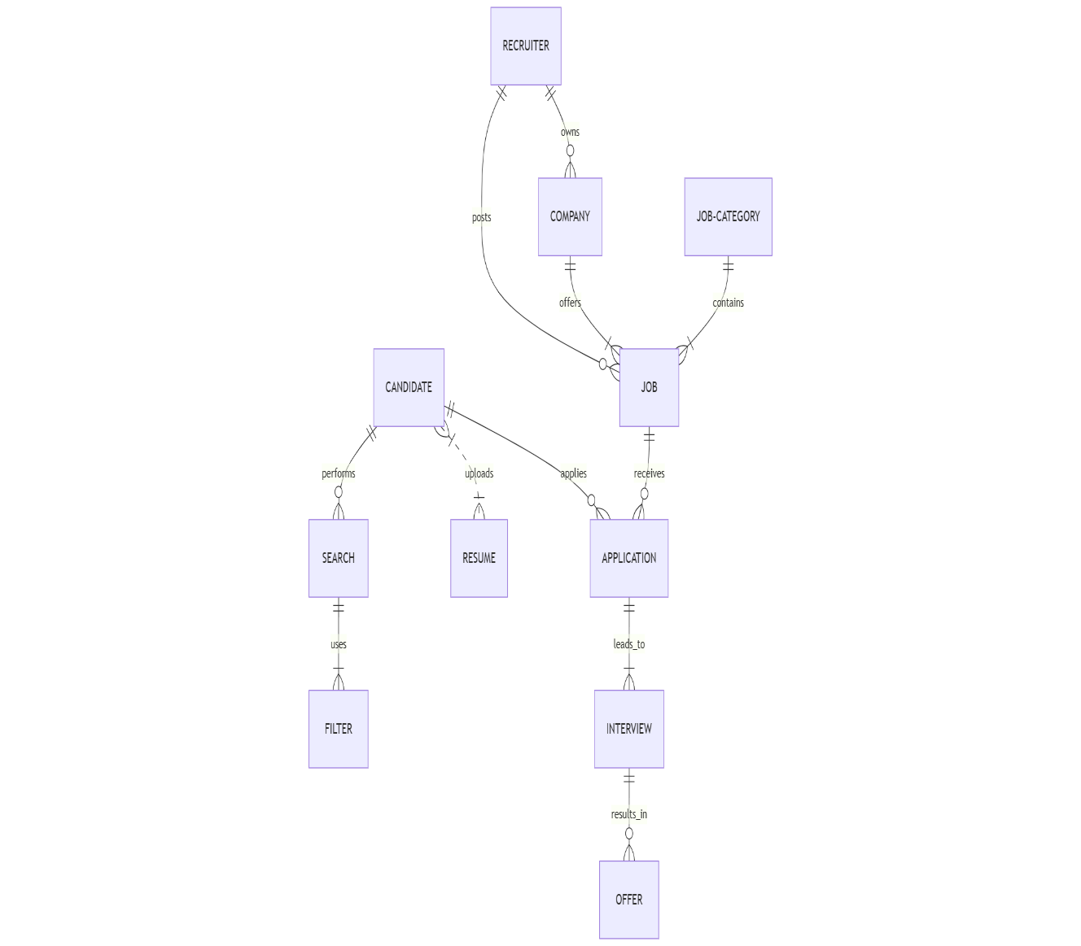

CHAPTER-6

PSUEDOCODE

// User Authentication

Function signUp(userDetails):
if userDetails are valid:
save userDetails in database
send confirmation email
return "Sign-up successful"
else:
return "Invalid details, please try again"

Function login(email, password):
if user exists in database and password matches:
create session for user
return "Login successful"
else:
return "Invalid credentials, please try again"

Function logout(userID):
end session for user
return "Logout successful"

// Candidate Profile Management

Function createProfile(candidateDetails):
if candidateDetails are valid:
save profile in database
return "Profile created successfully"
else:
return "Invalid profile details"

Function editProfile(candidateID, updatedDetails):
find candidate by candidateID
if candidate found:
update profile with updatedDetails
return "Profile updated successfully"
else:
return "Candidate not found"

// Job Posting (Recruiter)

Function postJob(recruiterID, jobDetails):
if recruiter is logged in:
save jobDetails in job database
return "Job posted successfully"
else:
return "Recruiter not logged in"

// Job Search (Candidate)

Function searchJobs(searchCriteria):
filter jobs in database based on searchCriteria
if jobs found:
return list of filtered jobs
else:
return "No jobs found.”

// Apply for a Job (Candidate)

Function applyForJob(candidateID, jobID, resume):
if resume is valid:
save application in database with candidateID, jobID, and resume
return "Application submitted successfully"
else:
return "Invalid resume"

// View Applications (Recruiter)

Function viewApplications(recruiterID, jobID):
if recruiter is logged in:
fetch applications for jobID
return list of candidates who applied
else:
return "Recruiter not logged in"

// Real-Time Application Tracking (Recruiter)

Function trackApplications(jobID):
fetch all applications for jobID
return list of applications with current status (pending, reviewed, etc.)

// Delete Job Posting (Recruiter)

Function deleteJob(recruiterID, jobID):
if recruiterID owns the job:
delete job posting from database
return "Job posting deleted successfully"
else:
return "Permission denied"

CHAPTER-7

EXPERIMENTS AND RESULTS

User Registration & Login:

Candidates and recruiters registered successfully with unique emails.

Login was tested with valid and invalid credentials

.

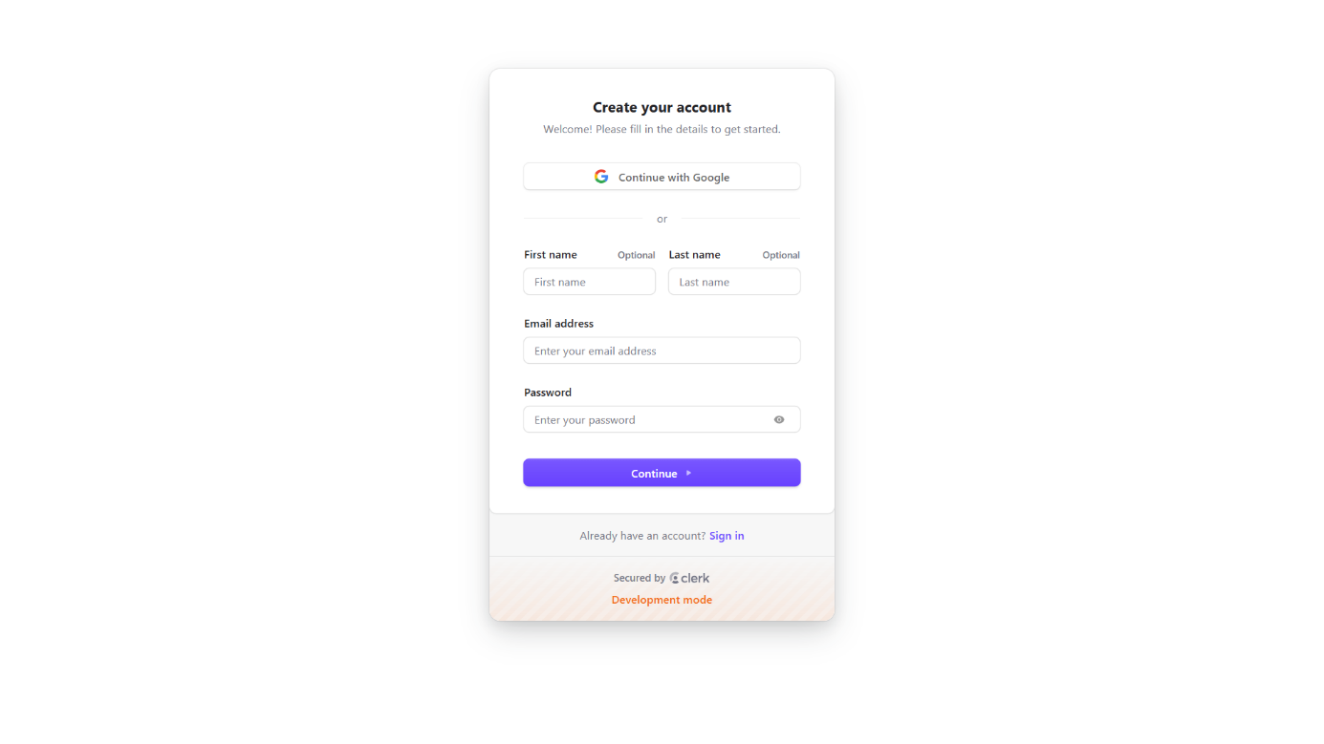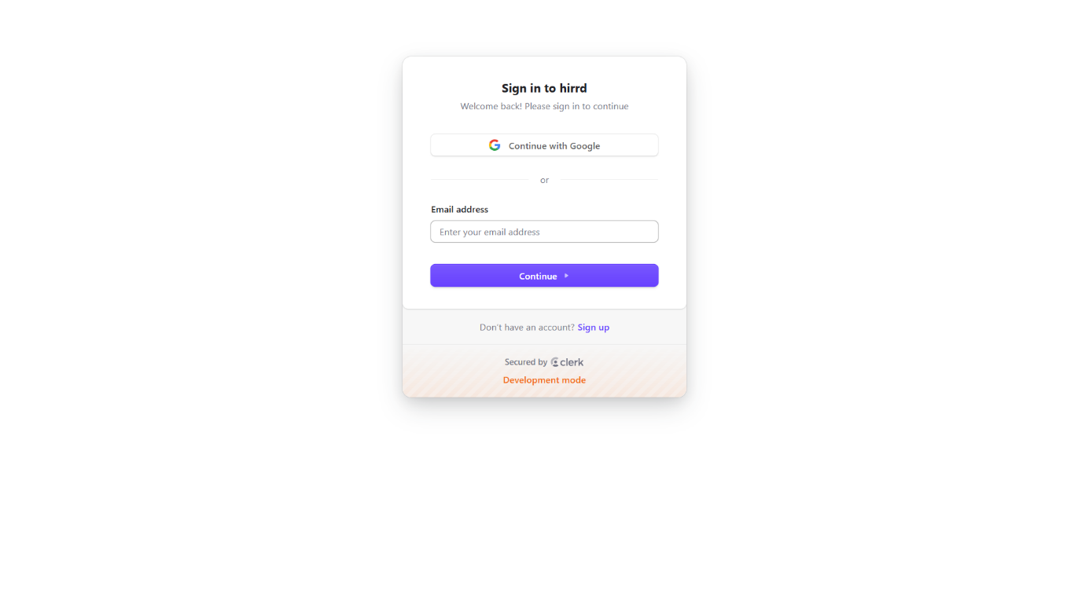

- Job Posting & Management:
- Recruiters successfully posted and deleted job listings.

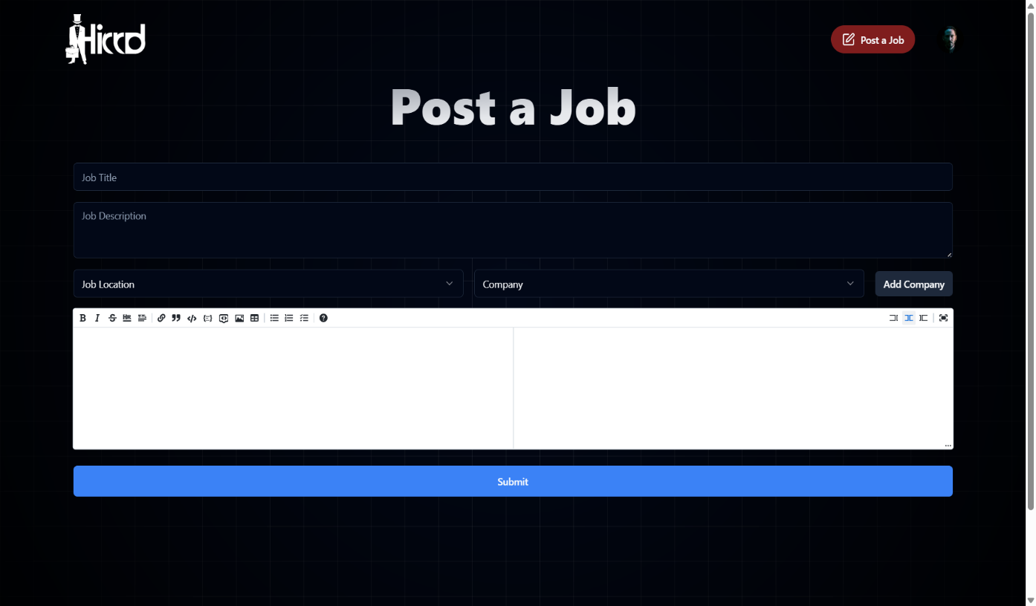

- Job Search & Filtering:
- Candidates were able to search for jobs using keywords.
- Filtering jobs by location and company worked correctly.

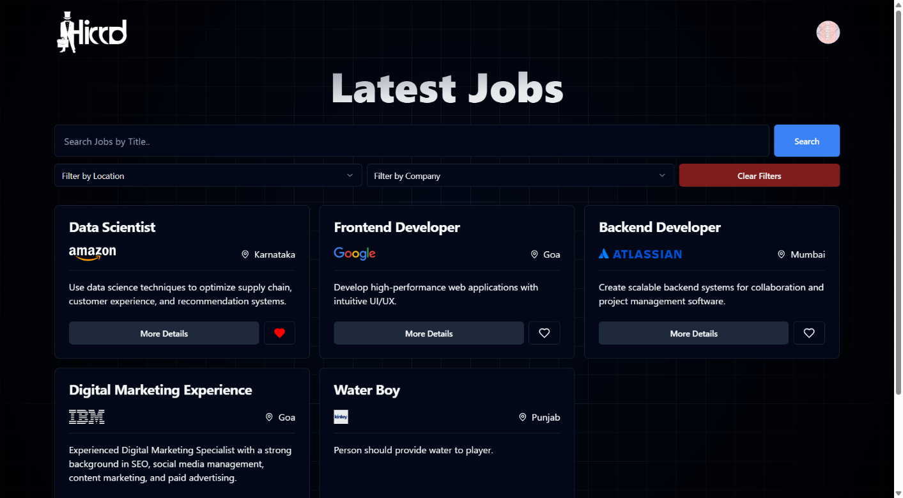

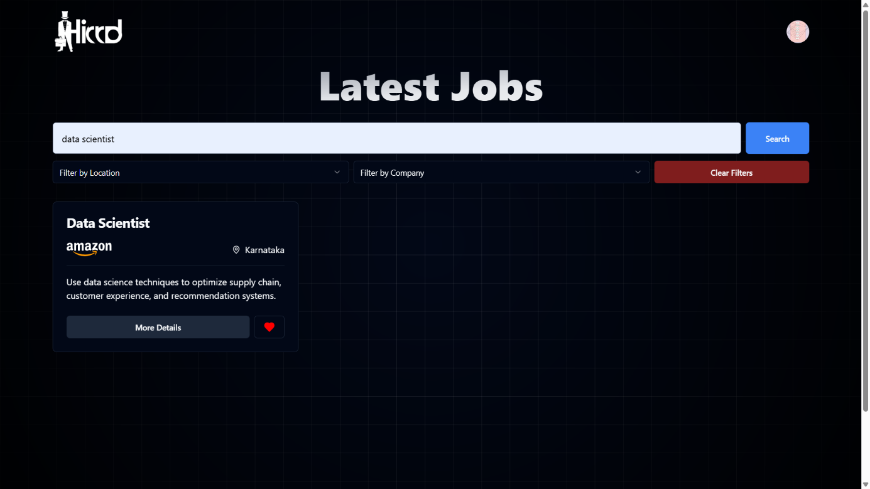

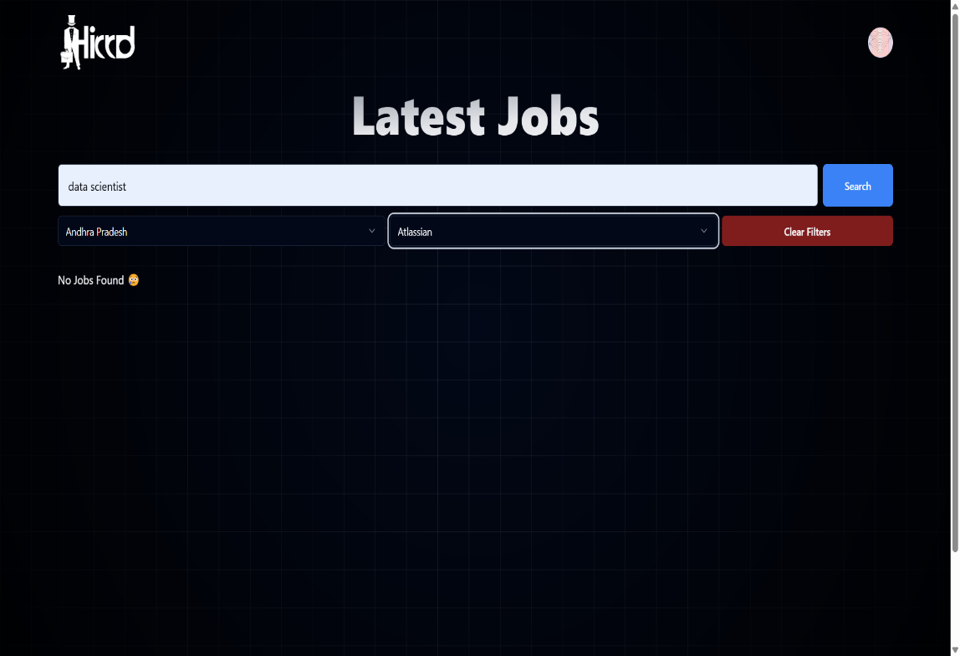

- Job Applications:
- Candidates applied for jobs with resume uploads.
- Recruiters accessed applied candidates' resumes.

Candidates:-

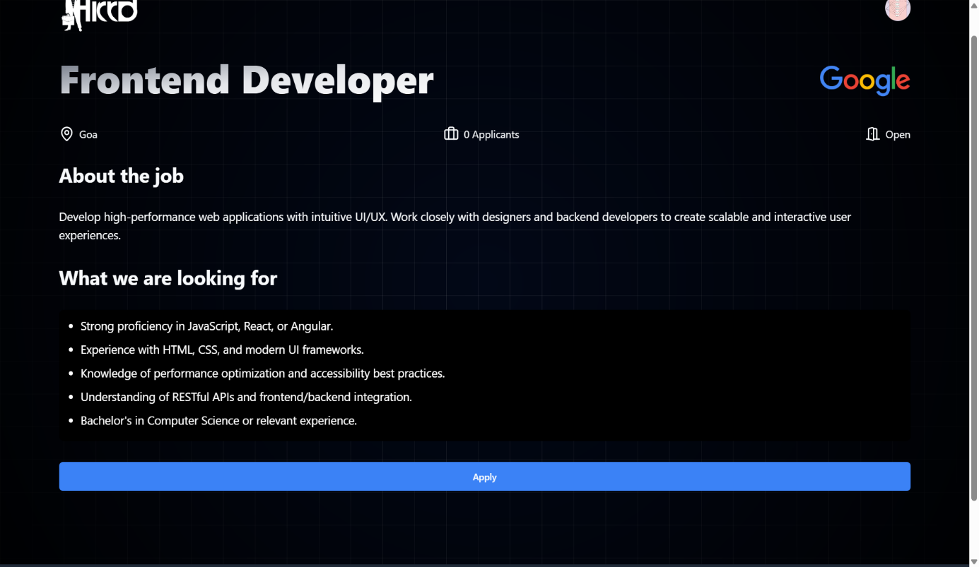
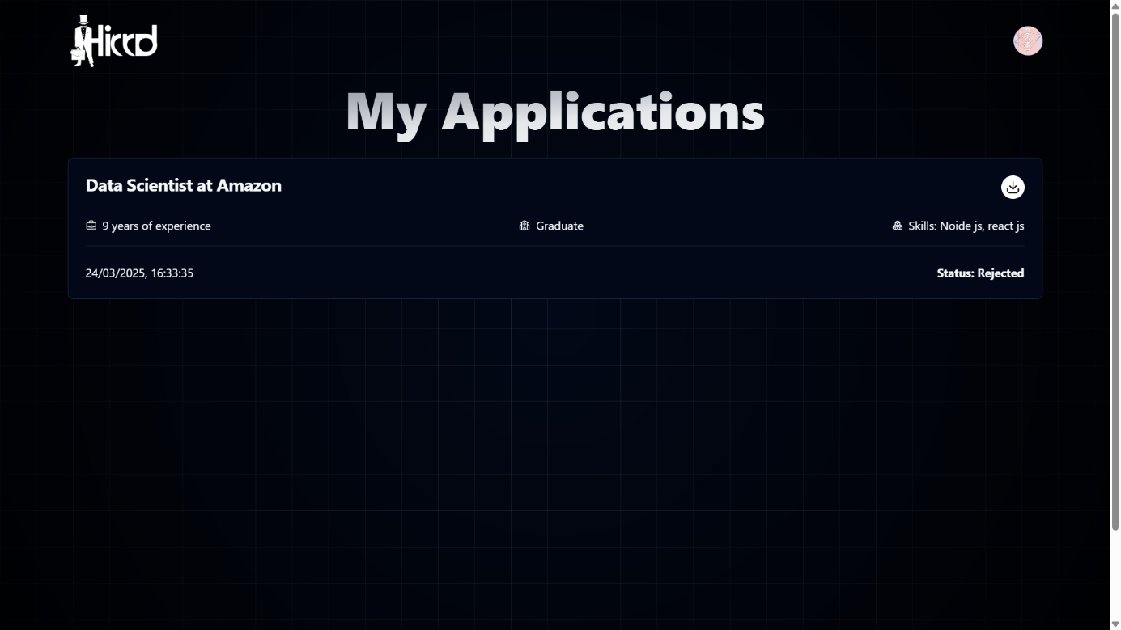

Recruiter:-

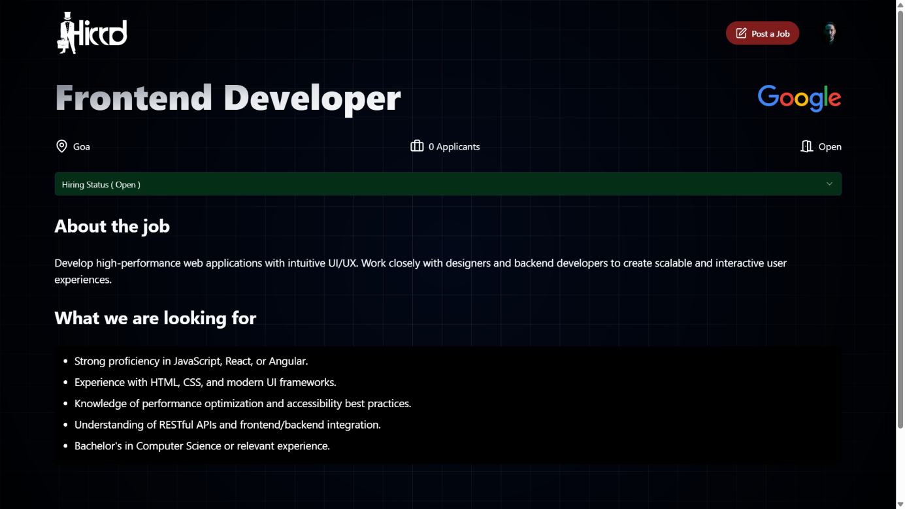

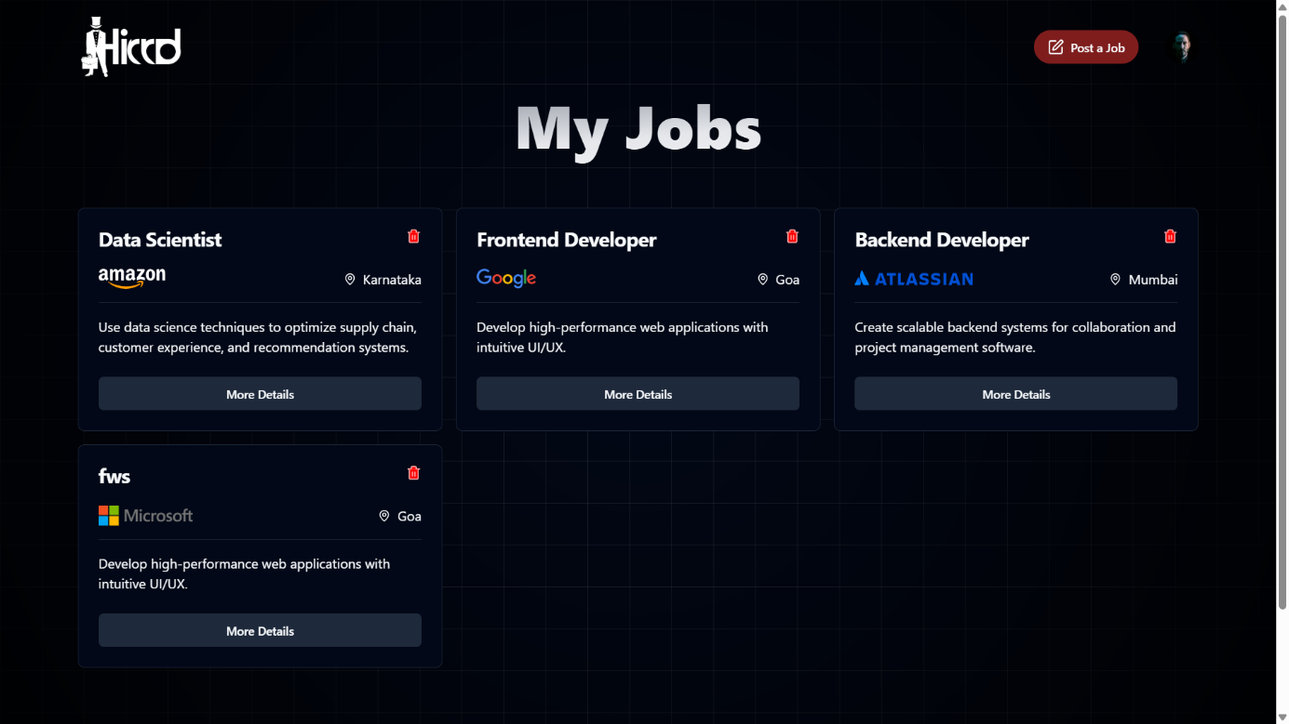

- Saved Jobs:
- Candidates successfully saved jobs and removed them from the saved list.

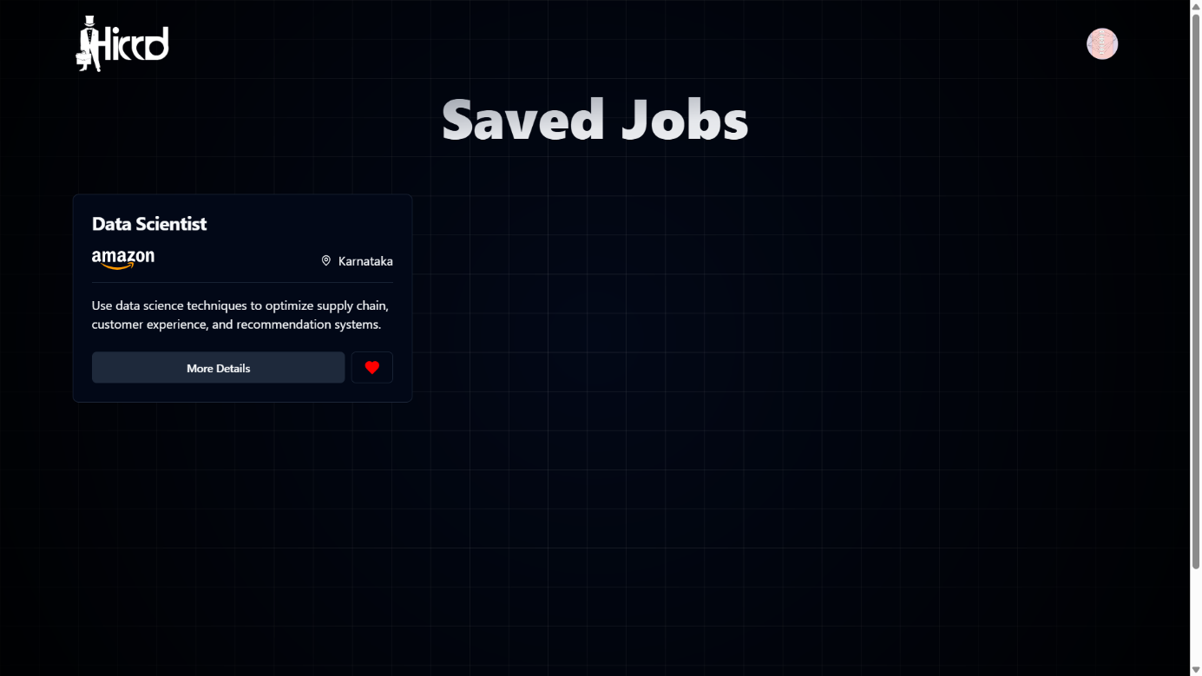

- Profile & Account Management:
- Users edited their profiles and deleted their accounts.

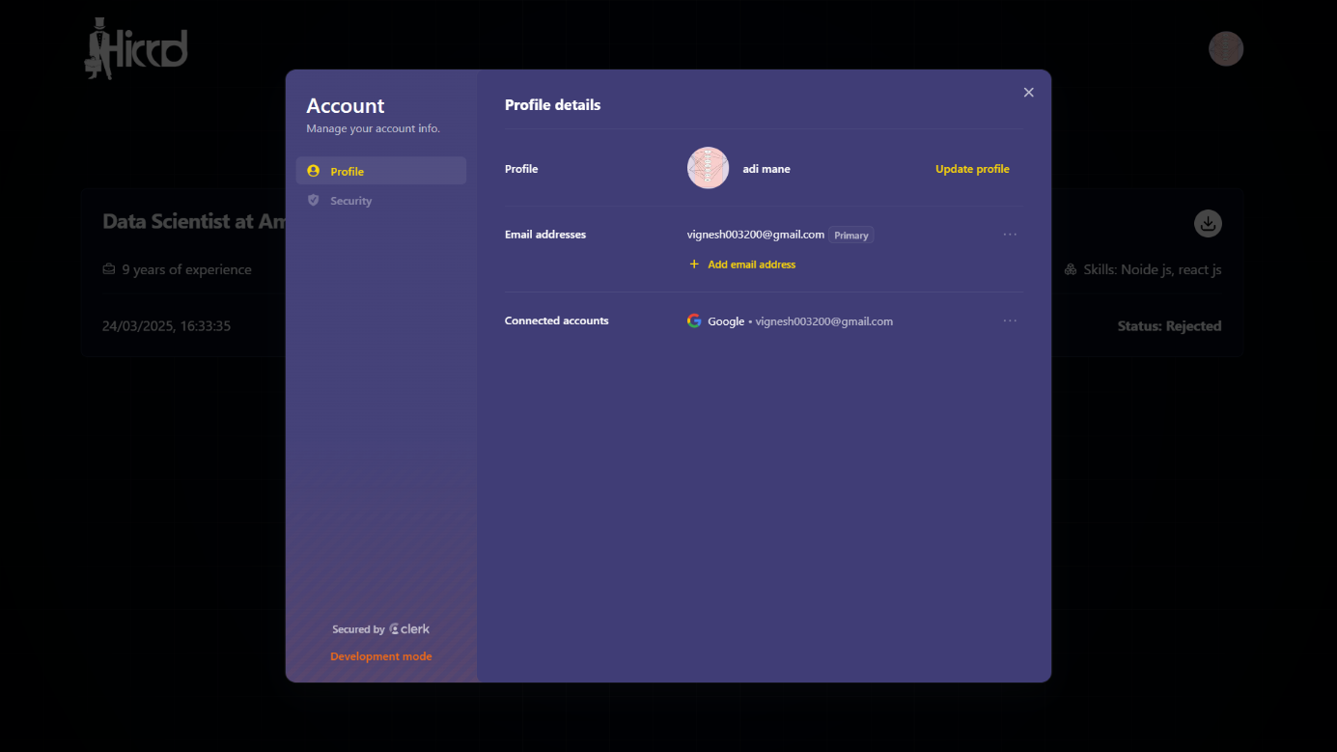

8. Test Cases

- User Authentication
Test Case ID | Test Scenario | Input Data | Expected Output | Status
TC-01 | Register a new candidate with valid details | Name, Email, Password | User account created successfully | Pass/Fail
TC-02 | Register with an existing email | Existing Email | Error message: "Email already exists" | Pass/Fail
TC-03 | Register with missing fields | Empty Fields | Error message: "All fields are required" | Pass/Fail
TC-04 | Login with correct credentials | Valid Email & Password | User redirected to dashboard | Pass/Fail
TC-05 | Login with incorrect credentials | Invalid Email or Password | Error message: "Invalid credentials" | Pass/Fail

- Job Search & Filtering (Candidate)
Test Case ID | Test Scenario | Input Data | Expected Output | Status
TC-06 | Search for a job | Job title or keyword | Relevant job  listings appear | Pass/Fail
TC-07 | Filter jobs by location | Selected location | Jobs from that  location appear | Pass/Fail
TC-08 | Filter jobs by  company | Selected company | Jobs from that company appear | Pass/Fail

- Job Application (Candidate)
Test Case ID | Test Scenario | Input Data | Expected Output | Status
TC-09 | Apply for a job with a resume | Resume uploaded and submitted | Application submitted successfully | Pass/Fail
TC-10 | Apply for a job without a resume | No resume uploaded | Error message: "Resume is required" | Pass/Fail
TC-11 | Check application status | Applied job list | Status updated correctly (Applied,  Interviewing , Hired,  Rejected) | Pass/Fail

- Job Posting (Recruiter)
Test Case ID | Test Scenario | Input Data | Expected Output | Status
TC-12 | Post a new job | Job Title, Description, Requirements, Location | Job posted successfully | Pass/Fail
TC-13 | Edit a posted job status | Modify job details | Job status updated successfully | Pass/Fail
TC-14 | Delete a posted job | Select a job and click delete | Job removed from the portal | Pass/Fail

- Candidate Management (Recruiter)

Test Case ID | Test Scenario | Input Data | Expected Output | Status
TC-15 | View applied candidates | Open applications list | Candidate details and resumes displayed | Pass/Fail
TC-16 | Download a candidate's resume | Click download button | Resume downloaded successfully | Pass/Fail
TC-17 | Shortlist a candidate | Select and mark as shortlisted | Candidate status updated | Pass/Fail

- Profile Management

Test Case ID | Test Scenario | Input Data | Expected Output | Status
TC-18 | Update candidate profile | Modify details and save | Profile updated successfully | Pass/Fail
TC-19 | Update recruiter profile | Modify company details and save | Updates reflected in profile | Pass/Fail

9. Future Scope
- AI-Powered Job Matching
Implementing machine learning algorithms to match candidates with jobs based on their skills, experience, and preferences.
- Advanced Filtering and Search
Integrating natural language processing (NLP) to allow for more flexible and intuitive search queries.
- Real-Time Notifications & Alerts
Adding SMS or email alerts for candidates when jobs matching their profile are posted.
- Video Interviews & Integration
Offering recorded video interviews as part of the application process for candidates to present themselves better.
- Advanced Analytics & Reporting for Recruiters
Enabling recruiters to track the success of job ads and optimize recruitment strategies.
- Social Media Integration
Allowing users to sign up or log in via social media platforms like LinkedIn.
- Employer Branding Tools
Helping employers attract candidates by highlighting the benefits of working for their organization.
- Integration with Job Marketplaces
Partnering with other job marketplaces or job boards to increase job listing visibility.

Conclusion
The development of a job portal presents several challenges that need to be carefully addressed to create a seamless and efficient platform for both job seekers (candidates) and employers (recruiters). Key challenges include user authentication, profile management, job search functionality, resume handling, and ensuring secure, real-time application tracking. Additionally, managing user roles and ensuring scalability and performance will be critical for the platform's long-term success.
By overcoming these challenges, the job portal will be able to deliver a user-friendly experience, helping candidates find suitable jobs and recruiters discover qualified talent quickly and efficiently. The ultimate goal is to provide an intuitive, secure, and scalable platform that enhances the job-seeking and recruitment processes for both parties, contributing to a more effective and streamlined job market.

Reference
Research Papers
- Han, L., Yang, K., & Zhang, Z. (2022). A Survey on Legal Judgment Prediction: Datasets, Metrics, Models, and Challenges. arXiv preprint arXiv:2204.12544.
- Suganthi, D., Sharmila, M., & Priya, S. B. (2021). An Efficient Job Portal Recommendation System Using Machine Learning Techniques. In 2021 International Conference on Intelligent Computing and Control Systems (ICICCS). IEEE.

Books
- Ian Goodfellow, Yoshua Bengio, and Aaron Courville. (2016). Deep Learning. MIT Press.
- E. Balagurusamy. (2019). Programming with Java. McGraw Hill Education.
- Jeffrey D. Ullman, & Jennifer Widom. (2008). A First Course in Database Systems. Pearson.
Web Sources
- Supabase Docs. (2025). The Open Source Firebase Alternative. Available at: https://supabase.com/docs
- W3Schools. (2025). HTML, CSS, JavaScript Tutorials. Available at: https://www.w3schools.com
- Mozilla Developer Network (MDN). (2025). Web Docs for JavaScript and Web APIs. Available at: https://developer.mozilla.org

